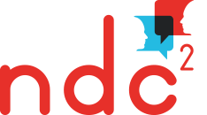
Proposal form workshops
‘Crossing borders, linking lives’
4 – 5 July 2019

Duration of the workshops is 1 hour. The closing date for proposals is 28 February 2019.

Please use this submission-form, particularly maintaining the headings. It would be helpful if you also could give some answers to the questions below. Thank you!

Proposal title

Name of author(s)

Abstract (max. 150 words)

Questions

- Why do you want to share your work?

- Which narrative theoretical concepts, skills of narrative practice or innovations do you want to present or discuss?

- What key themes are covered in your workshop?

- How will you consider relational ethics and narrative principles in your presentation? How will you address the politics of representation? (For example, what steps will you take to ensure that anyone you may talk about during the workshop maintains control over how they are represented?)

Please use these questions as a guiding line for your abstract

Please return your workshop proposal to:
info@ndc2.eu

